Step1 open the app to the main UI.

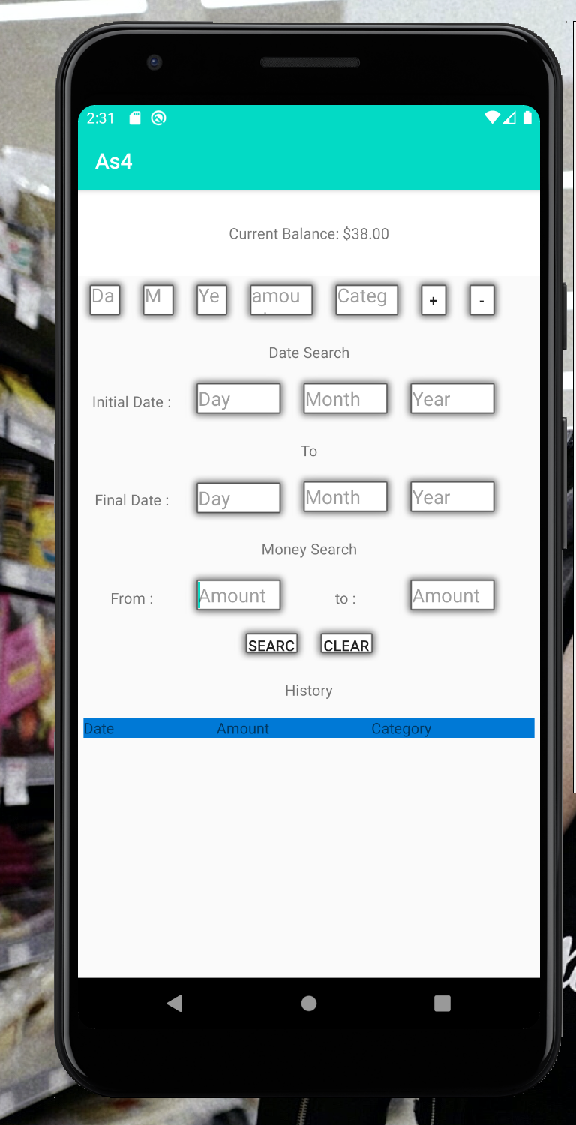

Step2 type the data to the phone and click “+”to record income, click “_”to record the cost.

Step3 , type the date which you want to see and click the “search” in the phone can see the detail.

Step4 type the amount which you want to see and click the “search” in the phone can see the detail.

